REPORT ON MACHINE LEARNING PROJECT

*TITLE* : **CAR RESALE PRICE PREDICTION USING MACHINE LEARNING**

*Project made by*: **1)Nagraj Gajjam**

**2)Rohan Dasari**

**3)Rahul Bodyal**

*INTRODUCTION*:

**Machine learning** is an application of artificial **intelligence** (AI) that provides systems the ability to automatically learn and improve from experience without being explicitly programmed. **Machine learning** focuses on the development of computer programs that can access data and use it learn for themselves.

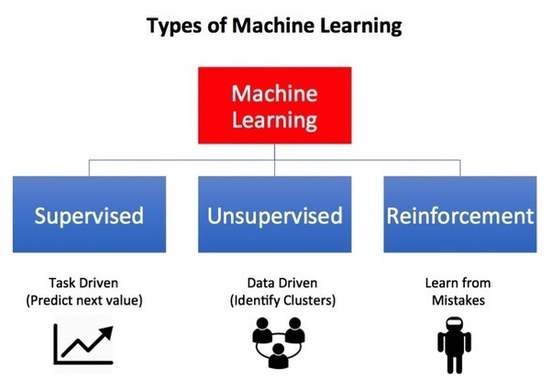

* The dataset is collected from various web resources in order to explore the used cars market and try to build a model that effectively predicts the price of the car based on its parameters (both numerical and categorical)
* It is seen always that the amount of time people spend discussing prices of heavily used cars, how they age and hold or loose value. And if you are going to sell your car, you have to spend some time finding similar cars in the catalog and trying to discover trends and figure out the fair price. And, more importantly, you have to withstand the stress of decision making regarding the price!
* So the idea for this project was to collect the data and build an effective model as quickly as possible, use the most effective tools available and explore the decision making of the model thoroughly.

*General Approach*:

**Regression** analysis is a subfield of **supervised machine learning**. It aims to model the relationship between a certain number of features and a continuous target variable.

* **Regression** models a target prediction value based on independent variables. ... Linear **regression** performs the task to predict a dependent variable value (y) based on a given independent variable (x).

*Sample results*-  
1)**Decision tree**:

Because of huge data in dataset, They are often relatively inaccurate. Many other predictors perform better with similar data.

2)**Multilinear algorithm**:

Multilinear algorithm has given better accuracy than decision tree. The accuracy increased to 0.5989 i.e. 59.89%

3)**Polynomial regression**:

For our given dataset,**Polynomial** provides the best approximation of the relationship between the dependent and independent variable. The accuracy increased to 0.8255 i.e. 82.55%

*Conclusion*:

* For our given dataset we found that among all the regression algorithm that targets prediction value based on independent variables we conclude that **Polynomial Regression** proves to be best algorithm.
* It provides highest accuracy among all algorithms.

*Reference* :

* Dataset link-<https://www.kaggle.com/lepchenkov/usedcarscatalog>